**HALL BOOKING**

Render URL: <https://hall-booking-h9vg.onrender.com>

Get Rooms data: <https://hall-booking-h9vg.onrender.com>/rooms/all

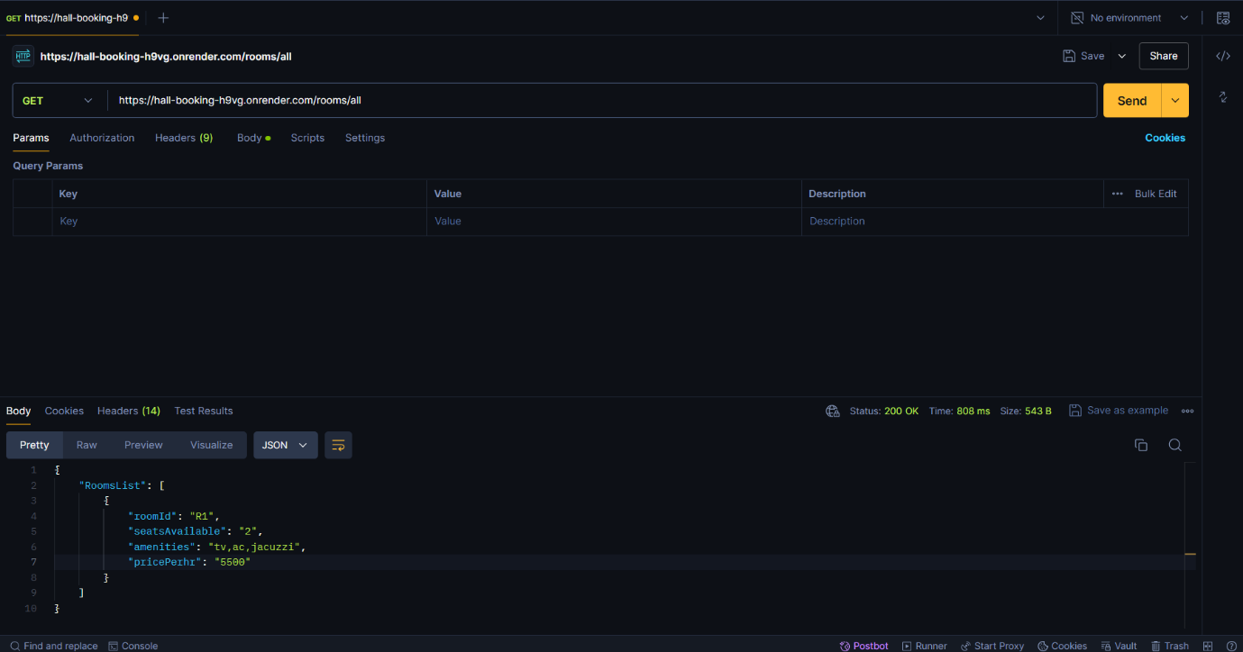

Get Rooms data: <https://hall-booking-h9vg.onrender.com>/rooms/viewbooking

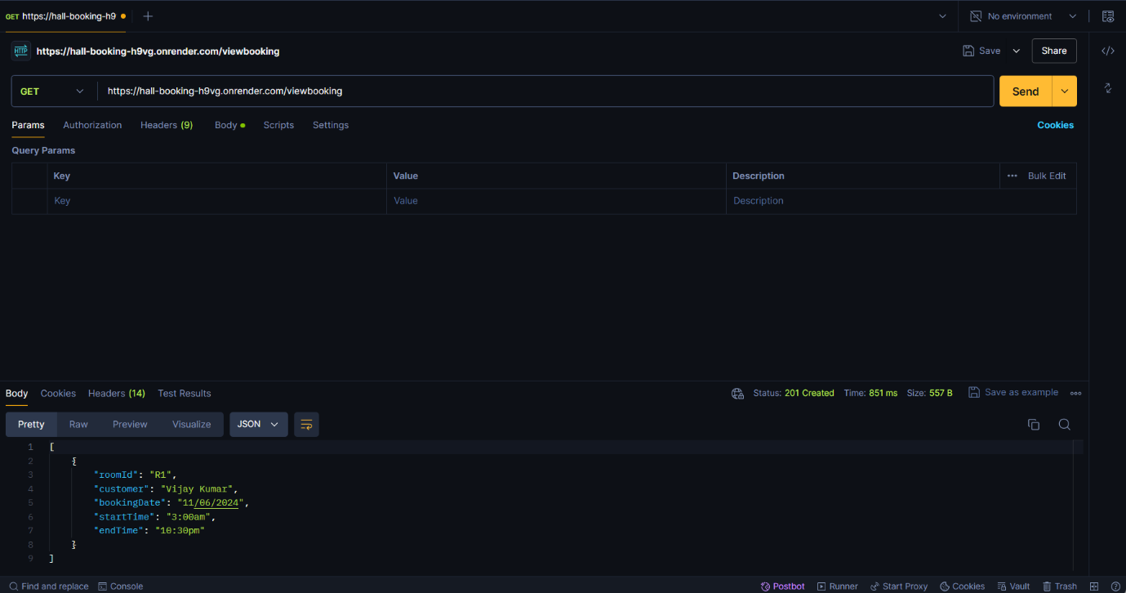

Get Rooms data: <https://hall-booking-h9vg.onrender.com>/customers

